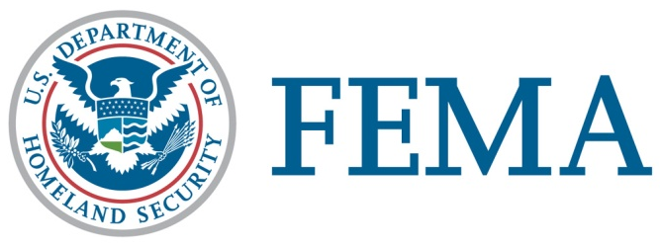

Congressional Affairs Division
202-646-4500

State of Washington

Federal Disaster Declaration Fact Sheet

APRIL 7, 2026

On April 7, 2026, President Donald J. Trump granted a Major Disaster Declaration for the State of Washington triggering the release of federal funds to help people and communities recover from the Severe Storms, Straight-line Winds, Flooding, Landslides, and Mudslides that occurred December 5-19, 2025. Details of the disaster declaration and assistance programs are as follows:

Declaration Number: | FEMA-4906-DR-WA
Incident: | Severe Storms, Straight-line Winds, Flooding, Landslides, and Mudslides
Incident Period: | December 5-19, 2025
Federal Coordinating Officer: | John F. Harrison  National FCO Program
Individual Assistance (IA): | (Assistance to individuals and households):
IA-Designated Areas: | Chelan, Grays Harbor, King, Lewis, Pacific, Pierce, Skagit, Snohomish, Thurston, and Whatcom Counties, including the Confederated Tribes of the Chehalis Reservation, Lummi Nation, Muckleshoot Indian Tribe, Nisqually Indian Tribe, Nooksack Indian Tribe, Puyallup Tribe, Quinault Indian Nation, Samish Indian Nation, Sauk-Suiattle Indian Tribe, Shoalwater Bay Indian Tribe, Snoqualmie Indian Tribe, Squaxin Island Tribe, Stillaguamish Tribe of Indians, Swinomish Indian Tribal Community, Tulalip Tribes, and the Upper Skagit Indian Tribe.
Public Assistance (PA): | (Assistance for emergency work and the repair or replacement of disaster-damaged facilities):
PA-Designated Areas: | Asotin, Chelan, Clallam, Clark, Cowlitz, Garfield, Grays Harbor, Island, Jefferson, King, Kittitas, Klickitat, Lewis, Mason, Pacific, Pend Oreille, Pierce, Skagit, Skamania, Snohomish, Wahkiakum, Whatcom, and Yakima Counties, including the Confederated Tribes and Bands of the Yakama Nation, Confederated Tribes of the Chehalis Reservation, Cowlitz Indian Tribe, Hoh Indian Tribe, Jamestown S’Klallam Tribe, Kalispel Tribe of Indians, Lower Elwha Klallam Tribe, Lummi Nation, Makah Tribe, Muckleshoot Indian Tribe, Nooksack Indian Tribe, Puyallup Tribe, Quileute Tribe, Quinault Indian Nation, Samish Indian Nation, Sauk-Suiattle Indian Tribe, Shoalwater Bay Indian Tribe, Skokomish Indian Tribe, Snoqualmie Indian Tribe, Squaxin Island Tribe, Stillaguamish Tribe of Indians, Swinomish Indian Tribal Community, Tulalip Tribes, and the Upper Skagit Indian Tribe.
Hazard Mitigation (HM): | (Assistance for actions taken to prevent or reduce long term risk to life and property from natural hazards):
HM-Designated Areas: | Under Review.
OTHER: | Additional designations may be made at a later date if requested by the State and warranted by the results of further damage assessments.

###

